CS5590-0003: web/cloud/mobile programming
Part II Lab 2: Android Application Creation.
Fall 2018
UMKC
Kim-Ndor Djimadoumngar

Assignment: Mobile Application Programming Advanced Topics
I used Android Studio to create Manifest.xml, Activity_main.xml, layout style, and MainActivity.java, respectfully.
- AndroidManifest.xml
To give permissions to take pictures and save/write the content in an external storage.

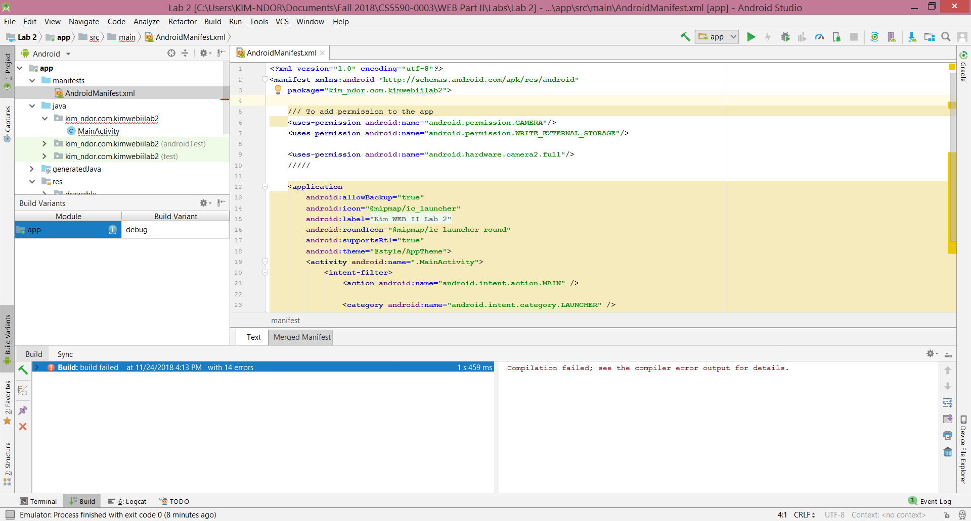

- Activity_main.xml
- To set the layouts and contents structures.
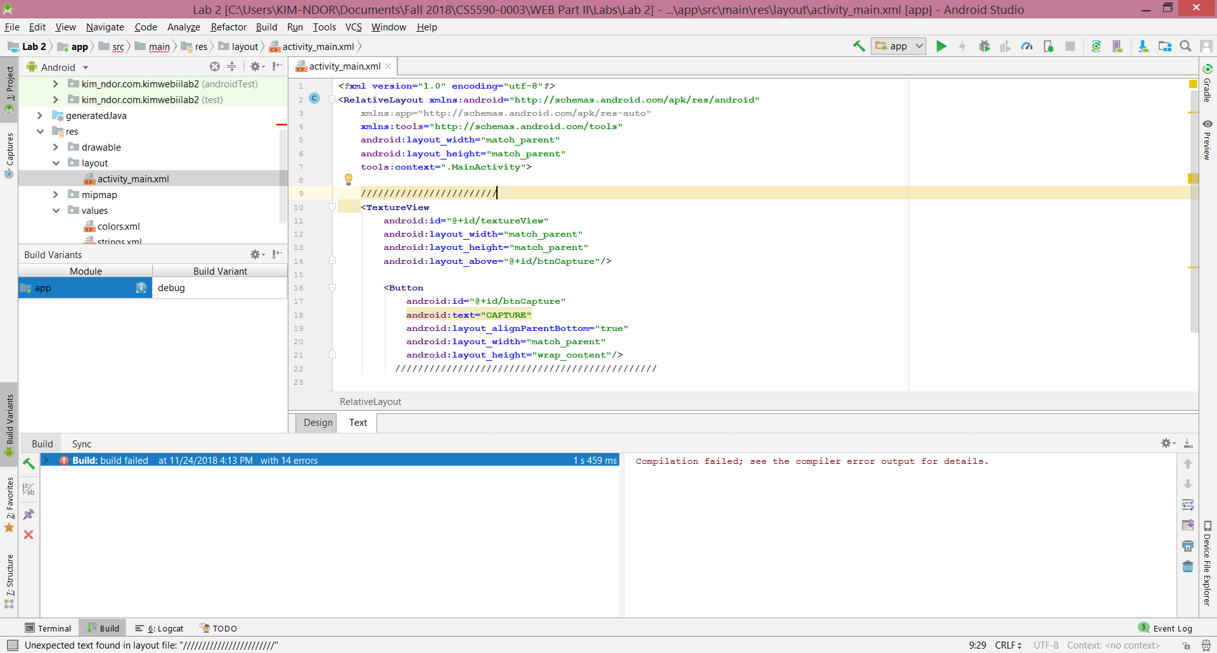
The design of the layouts is as below:
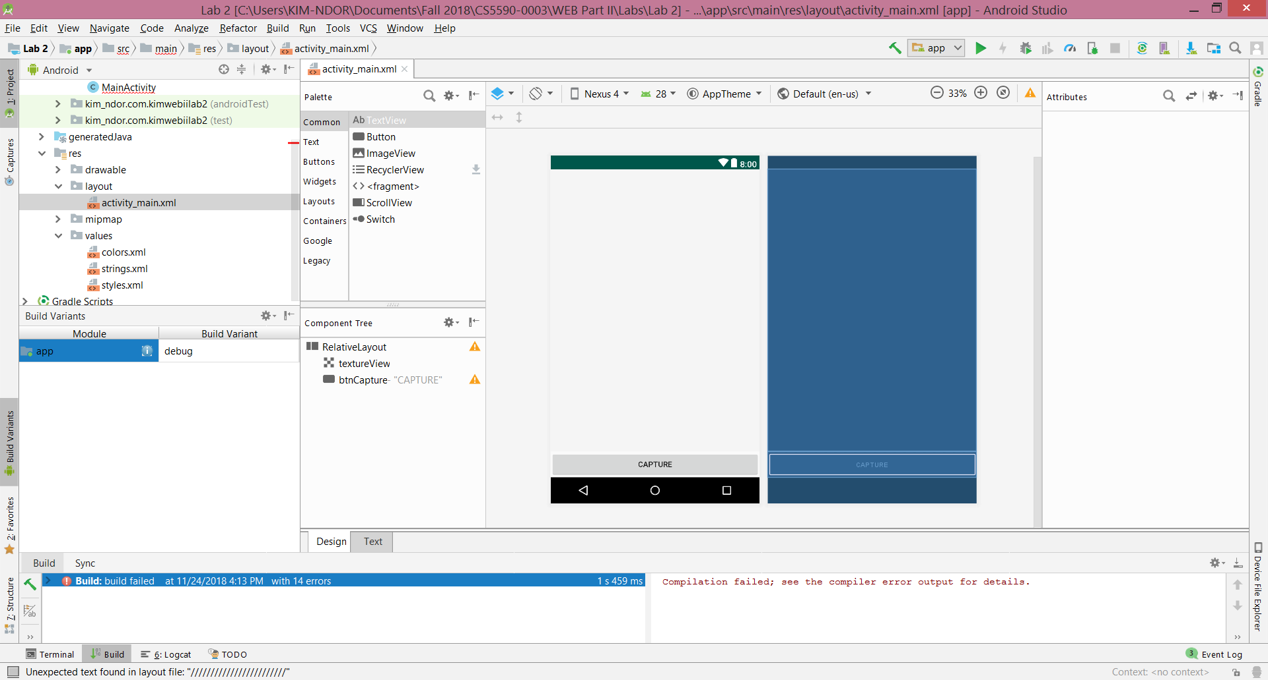
Style

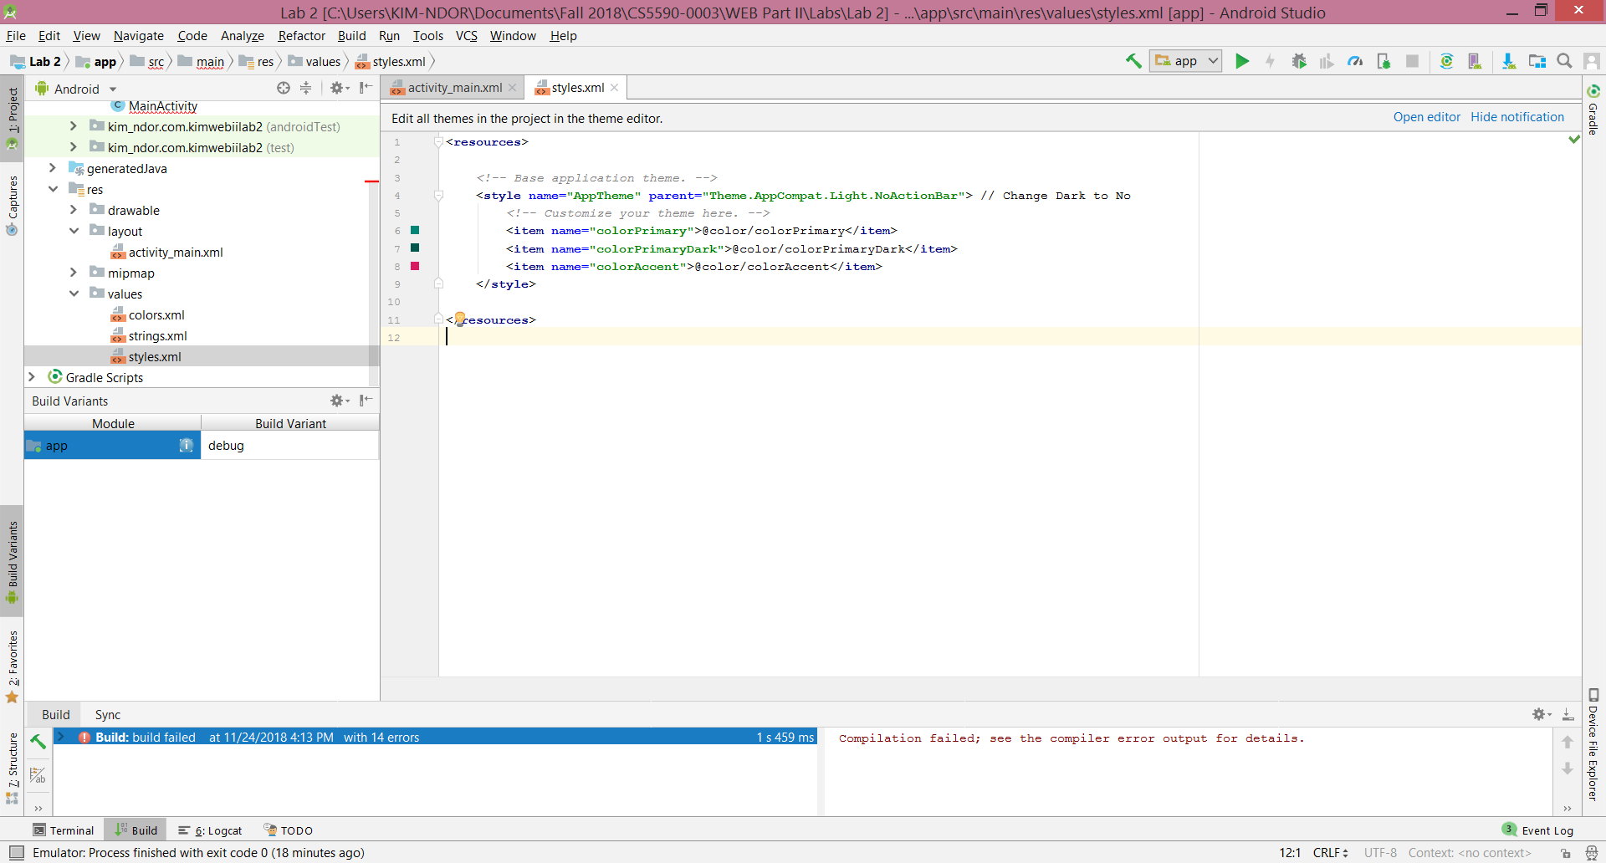

- MainActivity.java
A portion of the java codes leading to the output result are as in the screenshot below.
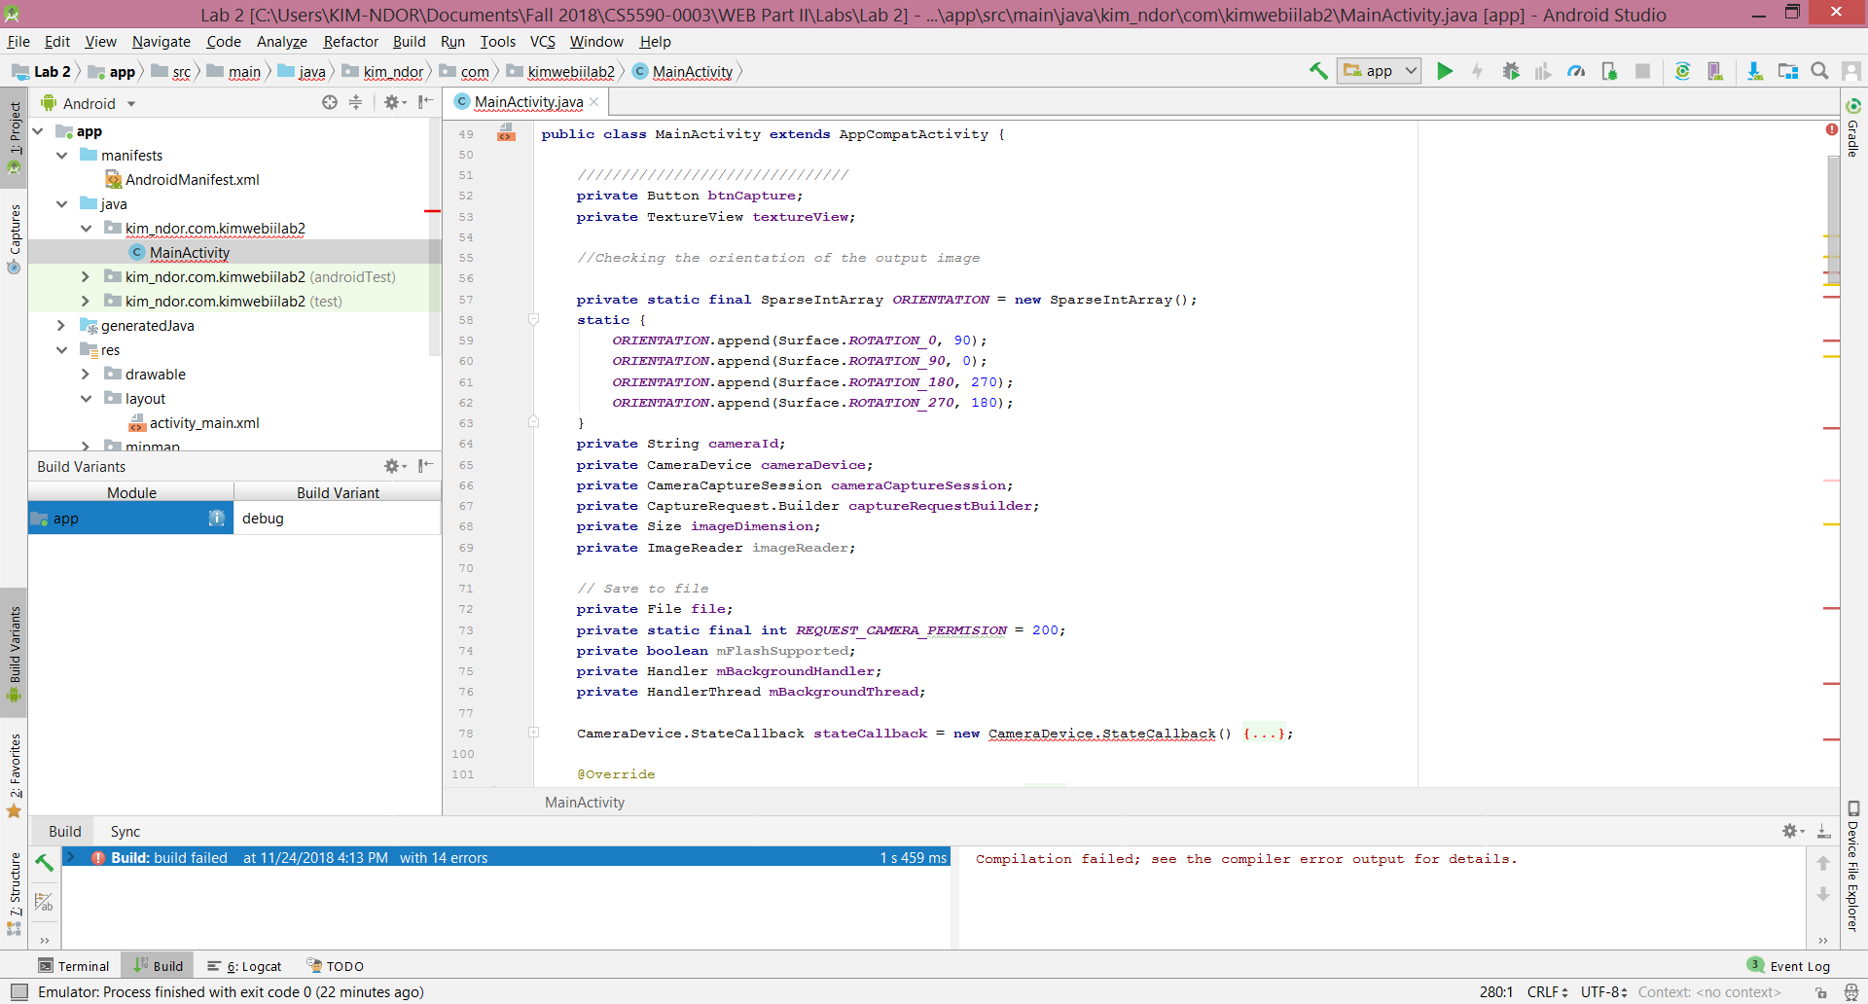
- Results
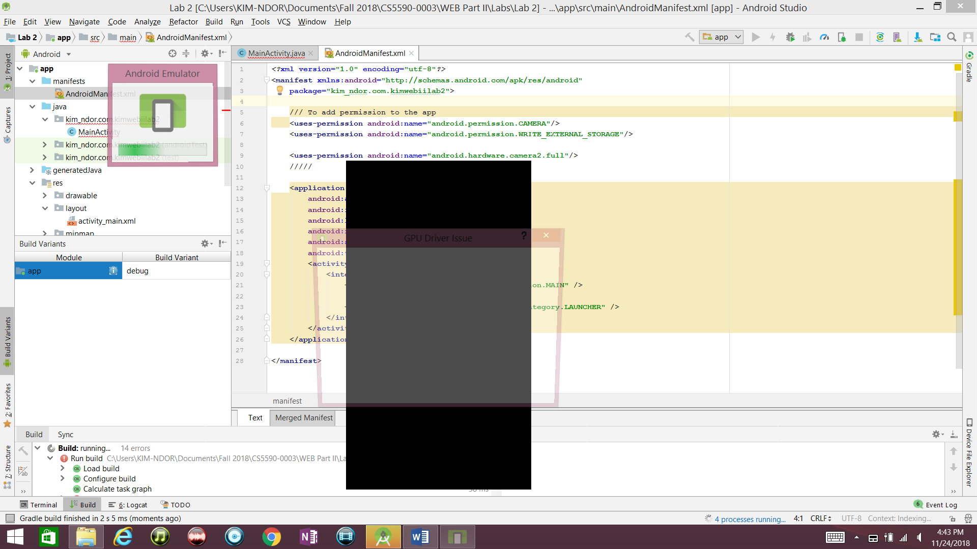
- Conclusion
Very good exercise to get hands dirty and be more exposed to java and android in general.

Reference
- https://www.androidhive.info
- https://developer.android.com/training/data-storage/sqlite.html
- https://www.tutorialspoint.com/android/android_sqlite_database.htm

